Join Domain using .hta file Guide

1. Run the cmd / poweshell as admin user, locate the file “.hta” path , select “Join_domain.hta” file then enter to run. Step -> 2

* use tab button for quick match

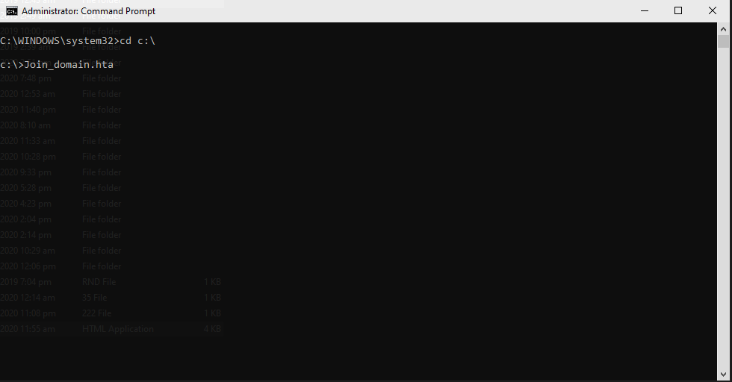

1. In “Join_domain.hta” , input the new computer name then submit -> Step 3.

Notes: 1. The new computer name input will automatically Caps whether you input a small caps

2. Make sure not to use a “SPACE” in your computer name. Use – (dash) or ( _ ) underscore instead ex.( New-pc )

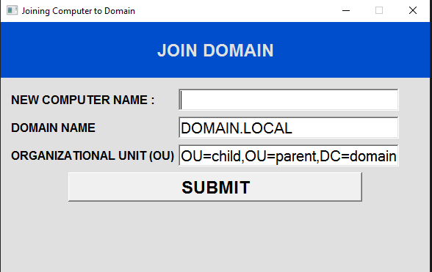

1. Make sure that Powershell is running as Administrator to execute the command successfully.
   1. Input the administrator username (user@domain.local ) and password.
   2. Wait for couple of minutes then the computer will automatically restart.

Notes : When you accidentally use an incorrect name, Kindly follow these procedure.

1. Unjoin the computer to the domain.
2. Delete the incorrect name in the DC located in the OU
3. Disconnect the workstation at least 15 mins in the network. -> It will helps to avoid getting the same Unique ID of the pc.
4. Try joining it to the domain again.
5. You can customize the script using notepad